**Computer Graphic**

**Need for Speed 2**

|  |  |  |
| --- | --- | --- |
| **Name** | **Section** | **BN** |
| **Ahmed Mohamed Abdel Hamed** | **1** | **10** |
| **Ahmed Mahmoud El Ghareeb** | **1** | **11** |
| **Ziyad Hassan Abdel Maqsoud** | **1** | **35** |
| **Omar Mohamed Abdel Fatah** | **2** | **6** |

**Game Description**

Need for Speed 2 is a 3D car game that is built on our game engine coded in C++, and OpenGL.

The idea of our game is that a car needs to reach a specific location, but it has a limited amount of health that is reduced as time passes. so, it needs to collect hearts along its way and avoid obstacles that also reduce health.

The speed of the car is relative to its health, so having more health is always better.

On its way, the car collects bags of coins, it must collect at least half of these coins or the whole mission will be failed.

Main Components

1) Car:

When the game starts the car starts to move along the way to the finish line with speed relative to its health,

The car can move in the right, left, and up(jump) directions by pressing A, D, W on the keyboard respectively.

2) Danger Obstacles

This is the type of obstacle that you should avoid, it decreases car health, and the car can’t avoid them by jumping.

3) Heart Obstacles

This is the type of obstacle that increases the car’s health and speed, and the car can’t avoid them by jumping.

4) tree branch Obstacles

This is the type of obstacle that act as danger Obstacles but the car can avoid it by jumping

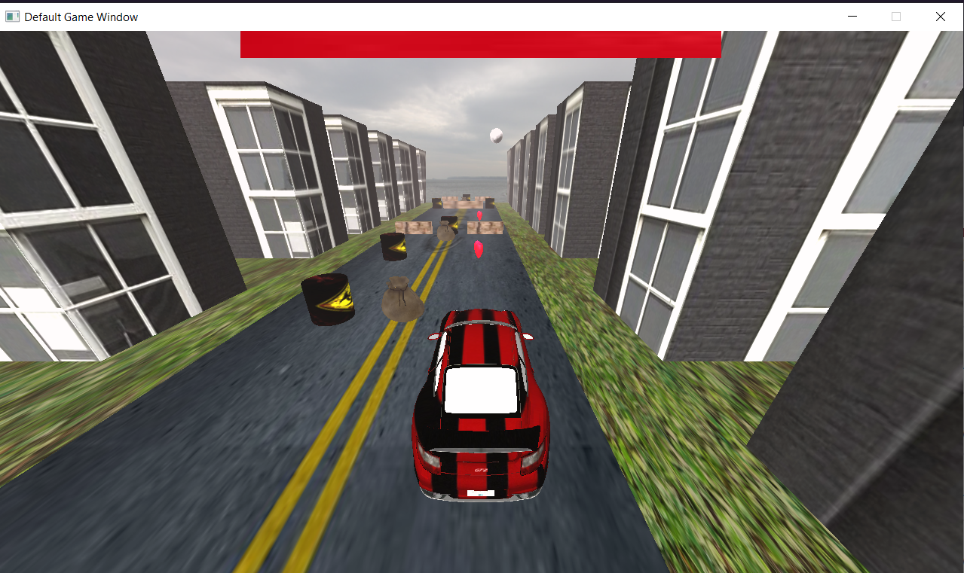Images from Game State:

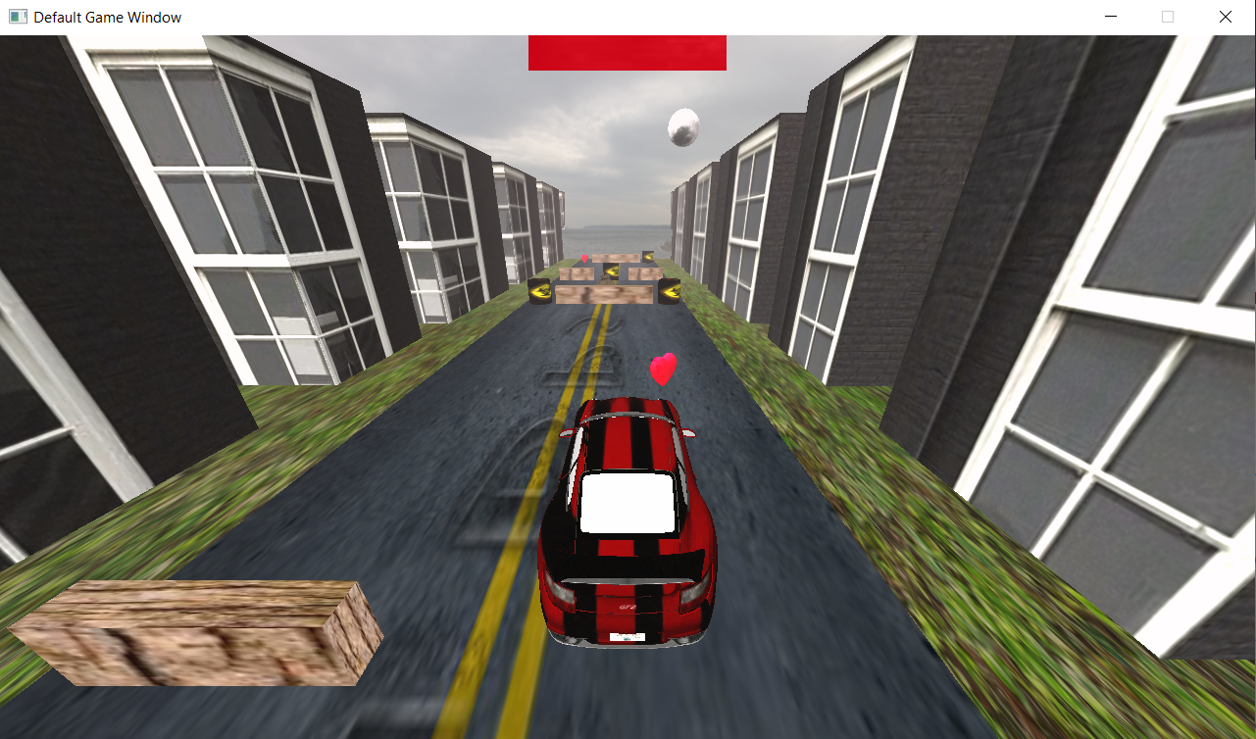

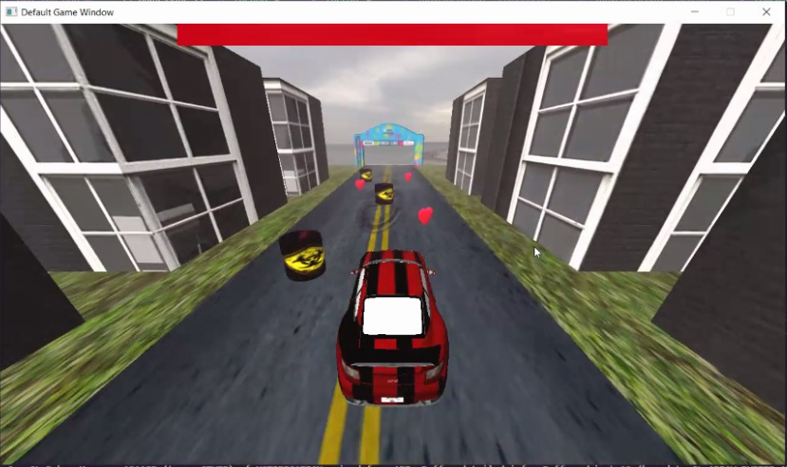

Images from Menu State

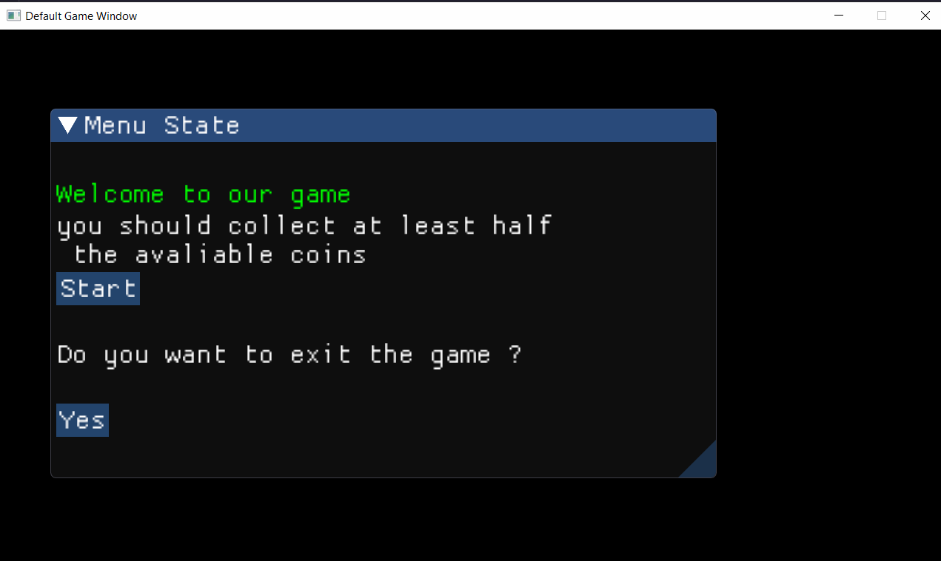

Images from GameOver State

